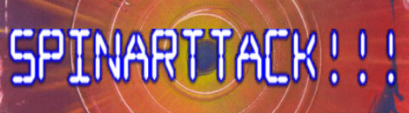
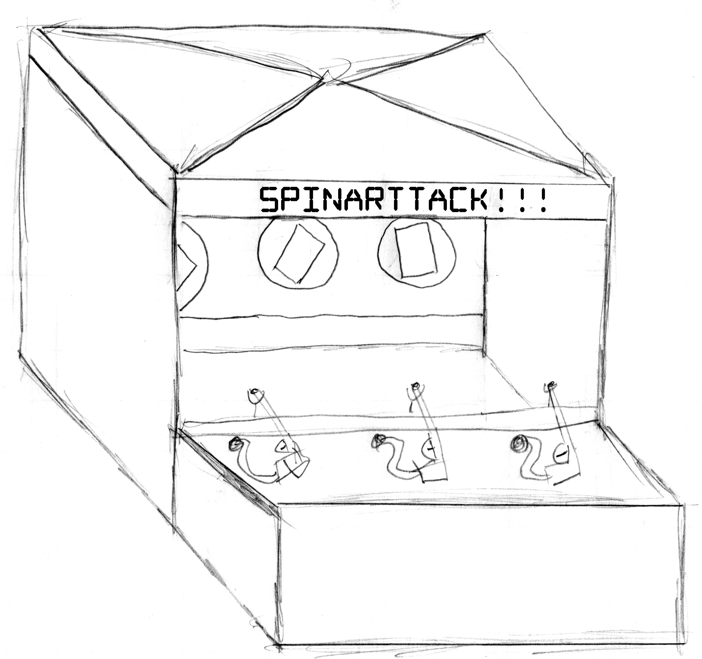Assembled SPINARTTACK!!! Booth Concept Drawing showing the canopy and tarp side-walls to contain paint.
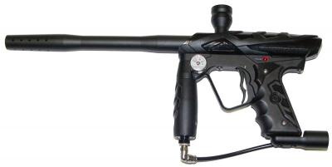
A typical Paint ball “marker”
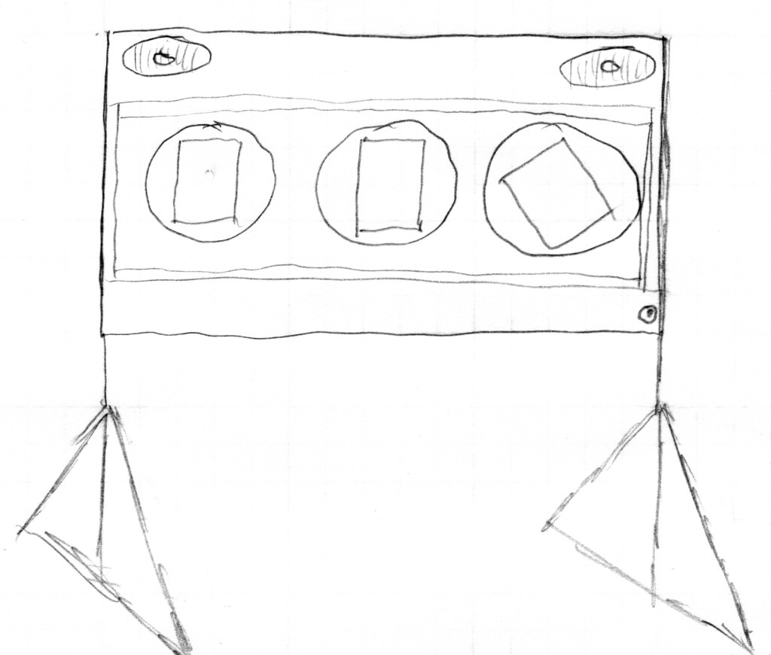
The targets will be spun at high speed to allow centrifugal force to create the signature “spin art” designs. Speaker systems will play exciting music and sound effects.
”Take a shot at creating vintage art!”

The concept for “SPINARTTACK!!!” is to use Paint ball guns (aka “markers”) to paint classic spin art paintings. Three spinning targets and three artists use the paint ball guns to launch paint balls while music and sound effects pump up the excitement. Mixing the thrill of a “FPS” (First Person Shooter) video game with the vintage spin art of the 70's, makes this a unique and entertaining attraction.

Overview
The SPINARTTACK!!! system consists of paint ball guns held in specially crafted “gimbals” to insure they can only be pointed towards the target range for safety and also to make it easier for artists to paint their targets. Each paint ball gun will have a “clip” with a limited number of paint balls to regulate the amount of coverage of the target. The target area will consist of a 8' by 4' plywood sheet that will hold three spinning targets brackets. Each bracket will contain a piece of paper approximately 11”x17” in size. Around the spinning targets will be a “paint baffle” to catch the excess paint thrown off by centrifugal force. Speakers mounted in the target area and in and under the table will produce the sound effects, music and commands for the artists. Strobe lights, rope lights and spinning beacons will add to the fun.

To enhance the night time excitement, UV reactive and “glow in the dark” paint balls will be mixed in with regular colors and the target range lit with black lights to make for a unique and entertaining show. As the paint balls fly toward the targets, they glow brightly under the black lights looking like “tracer” rounds and then flowering brightly into star bursts of colorful light on the targets.

A square 12' x12' “easy up” canopy will act as a roof for the shooting gallery. Tarps will be draped on the sides of the canopy to insure that all paint is kept within the attraction. The sides tarps will be clear plastic to allow observervation of the art as it is created.

Typical Operation
In operation, when three artists are ready to “paint”, an operator will trigger a microcontroller that will:

- Insure the gallery is clear
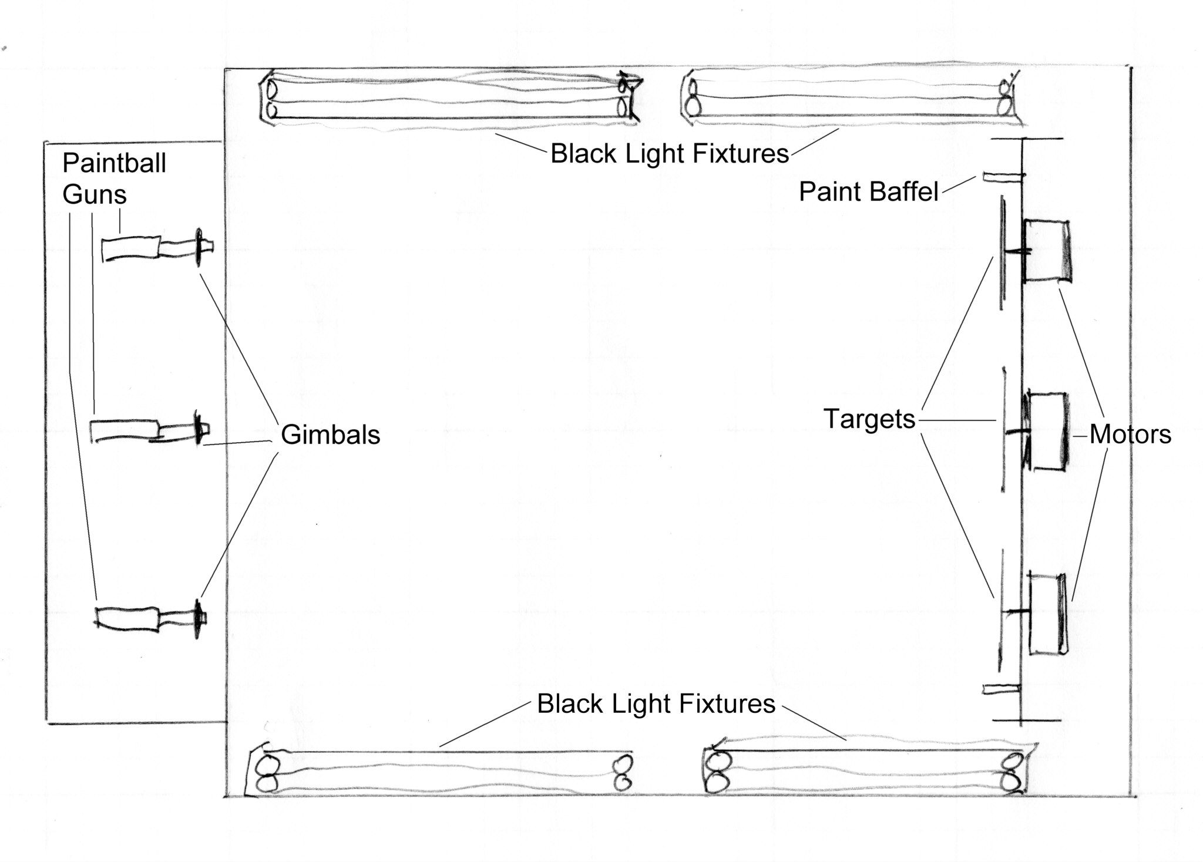
Top view of canopy with targets, lighting and gun assemblies
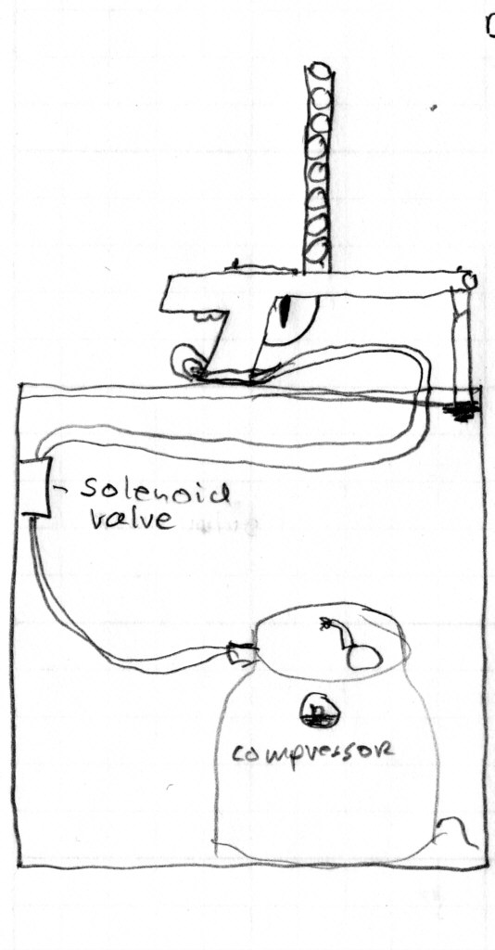
A solenoid valve is used to arm / disarm the paint ball guns. An air compressor allows the muzzle velocity to be limited to safe speeds.
- Start music and sound effects
- Start the targets spinning
- Enable the compressed air
- Play “Ready, Aim, CREATE!”

The microcontroller will automate the system to insure the safety of the artists and the operators. By digitally controlling the machinery we insure that a uniform experience is given to all people who participate.

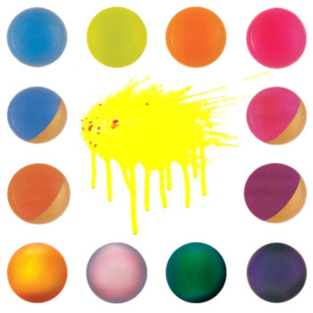
The distance from the paint ball guns to the targets will be approximately 10' allowing the air pressure for the guns to be lowered to just what is necessary to insure the paint balls “pop” on impact with the paper. Many different color paint balls will be randomly mixed to insure good color blending in the final art work. At night special “black light” reactive and Glow in the Dark paint balls will be mixed in to increase the spectacle and the excitement for both the artists and the observers.

Once the artists have either run out of ammunition or 30 seconds has elapsed, the microcontroller will:

- Play the “complete” music & instructions
- Deactivate the paint ball guns
- Stop the spinning targets

The operator can then remove the paintings from the target brackets and hand them to their respective artists. The paint will have been substantially dried by the high speed air moving over the paper as it spins allowing the finished artwork to be handled and carried without damage.

Many of the materials for the SPINARTTACK!!! are available locally and the attraction can be used both day and night. With a magazine of 24 paint balls, and a turnover time of approximately 3 minutes per round (1 minute to load paper, 30 seconds to seat the “clip” in the guns, 30 seconds of shooter time, 1 minute to retrieve and deliver art to artists). Gives us 20 “rounds”, times three people per round, for a total of 60 new artworks produced per hour.

With 3 guns, using 24 balls on each round, and with 20 rounds per hour, the attraction should use approximately 1440 balls per hour. Bulk paint balls come in 2000 count cases for approximately $40 per case, making the cost per hour of operation only about $35. That means that 60 people per hour can create otheir own original artwork in a fun and exciting way!

