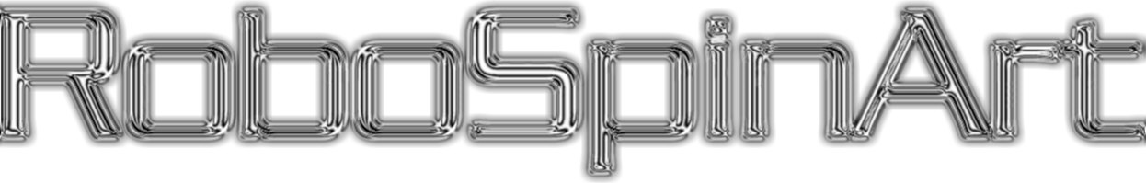
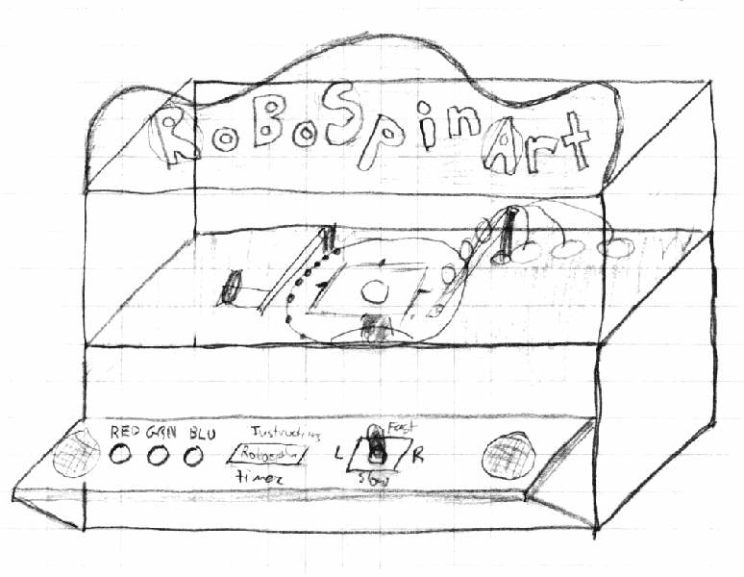
Concept Drawing
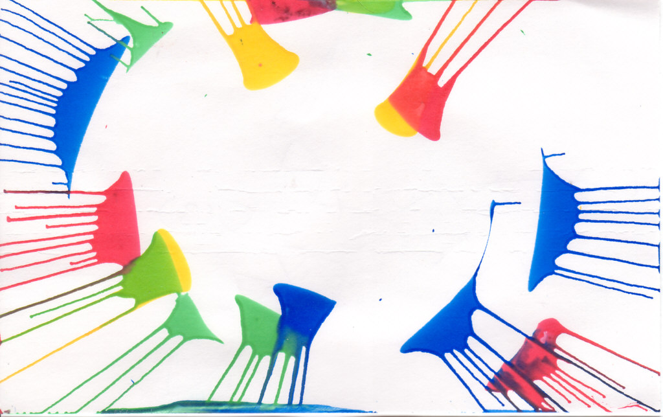
Low Speed Spin Art
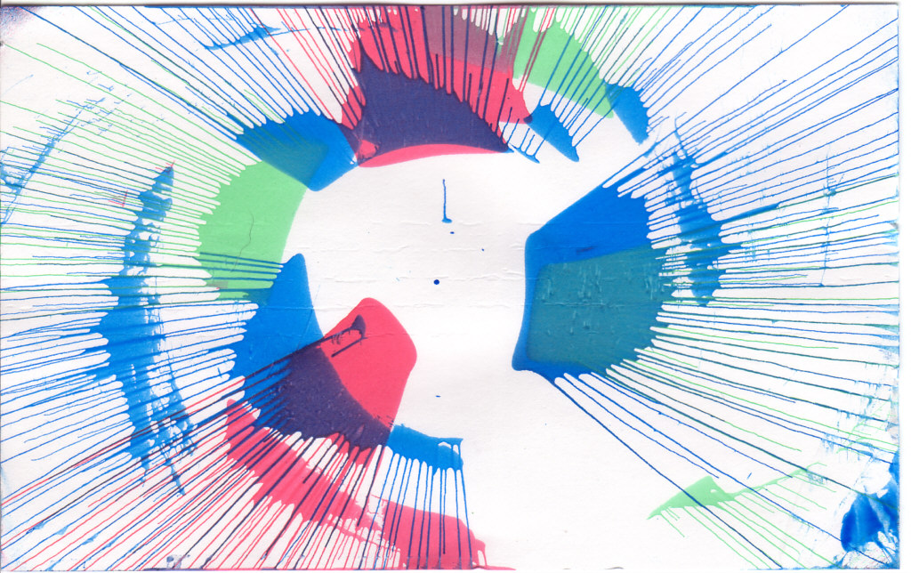
High Speed Spin Art

Retro
art
meets
the
Joystick
Generation
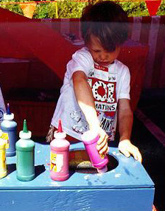Kid making a soggy mess of his paper.
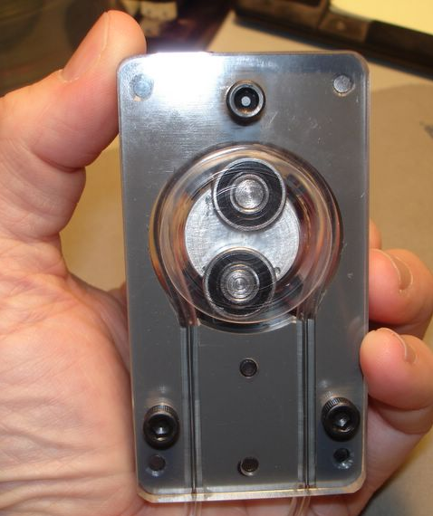Peristaltic pump

Overview
The venerable spin art machines of the 1960's & 70s created funky, psychedelic artwork many of us remember from the carnivals and county fairs of our youth. Simply put, “spin art” is created when paint is dropped onto a rotating paper, allowing centrifugal force to make streaks of color. The RoboSpinArt machine updates this concept by making spin art attractive to the so-called “joystick generation” of today while also overcoming some of the limitations of the original design.

The RoboSpinArt machine allows you to create spin art by using a joystick to position a “paint gantry” above the paper and a series of buttons to dispense paint in measured amounts. Add an exciting light show, a rocking sound track, and a countdown timer that creates a sense of urgency, and you have a RoboSpinArt machine!

Improving on the original
When presented with a “squirt bottle” full of paint, most children will simply squirt as much of it as they can onto the paper. This resulted in a soggy, saturated, monochromatic mess. In order to alleviate this problem, the RoboSpinArt machine will carefully dispense a limited amount of paint via small “peristaltic” pumps. Operated by a microcontroller, these peristaltic pumps will deliver a precise “shot” paint. The artist will be limited to a specific number of “shots”. This insures that the resulting artwork will not end up completely saturated, while still having enough paint to create the classic spin art look.

Don't know what you've got till its done..
Another common problem encountered in the older spin art machines was the inability to see your art work until the motor stopped spinning the turntable holding your paper. By the time the turntable had stopped spinning, it was too late to add paint or make changes that the final artwork might need. To allow the artist to preview their work, the RoboSpinArt will be equipped with a strobe light that will allow you to “freeze” the turntable and inspect your progress.

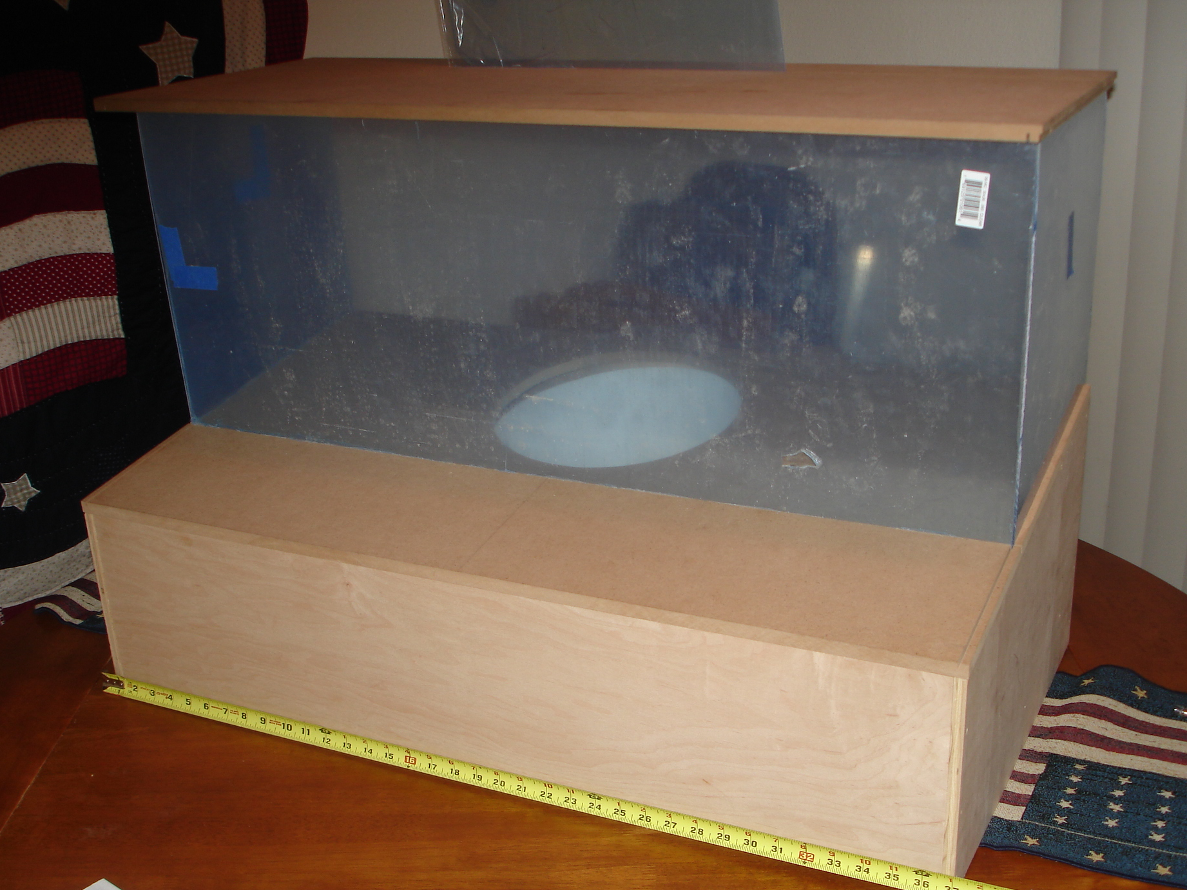
Mock up RoboSpinArt Cabinet
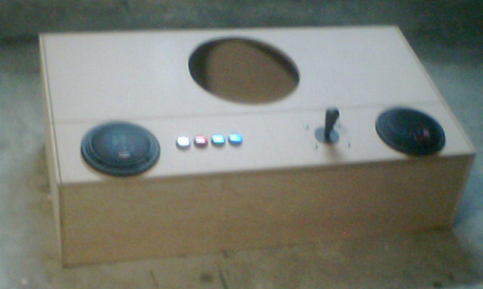Mock up RoboSpinArt control panel
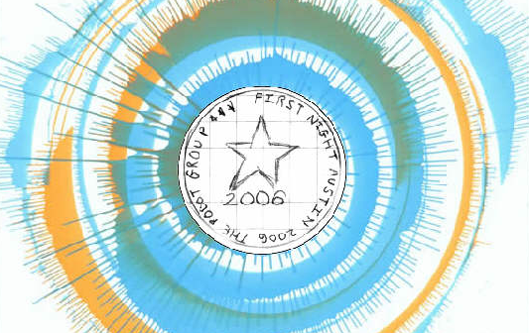
Mock up output showing the center logo and text

Faster! Slower!
As an added twist, the RoboSpinArt machine uses the up/down of joystick to alter the speed of the turntable. Acceleration and deceleration alters the paint effects leading to “swirling” or “bending” paint tendrils. Also, when the turntable is operating at high-speed, the paint tendrils tend to be very thin and the paint colors can become more “pastel” colored. At low speed, the tendrils are thicker and the colors tend to be bolder. The dynamic speed control of the turntable creates new opportunities for spin artwork.

Typical Operation
To operate the RoboSpinArt machine, a person behind the unit (the operator) will place a piece of paper on the turntable. Once th paper is placed and an artist is ready to begin, the operator presses a “start” button on the back of the cabinet.

At this point, the RoboSpinArt machine will drop a “print head” down onto the paper and inscribe a circular message onto the paper (see Mock up output). After the inscription, the turntable will spin up to the accompaniment of music. One up to speed the artists will be verbally signaled with a countdown of “3.. 2.. 1.. PAINT!” at this point they may choose to:

- Move the gantry left or right with the joystick
- Increase or decrease the speed of the turntable with the joystick
- Dispense paint using the pushbuttons
- Activate the strobe light with the pushbutton
- Hear sound effects accompany their actions

Once 30 paint shots or 30 seconds has elapsed, the turntable will spin down and the operator signaled to remove the painting. The operator unloads finished art and then reloads paper for next patron. When not actively painting, the RoboSpinArt will revert to “attract mode” where sounds and lights will try and entice people into trying their hand at creating art.

Throughput
With an expected turn around time of 3 minutes per artwork (1 minute to load the paper, 20 seconds to inscribe the message, 10 seconds to “spin up”, 30 seconds for the artist to “paint”, 1 minute to remove the paper and hand to the artist) each RoboSpinArt machine can entertain approximately 20 people per hour. If possible more than one machine should be built to increase the through put.

